**EchoVision User Documentation**

*(instructions below core features and functionalities)*

**Introduction**

According to the World Health Organization (WHO), there is an estimate of 43 million people blind across the globe, while another 295 million have some form of visual impairment (University of Bath, 2025). Many find it difficult to navigate, leaving them to rely on a human or animal companion. Whether they were born blind, became impaired due to an incident, being able to rely on a trusted AI application would not only improve the way they navigate, but improve their confidence when they choose to walk in a room without human assistance. This documentation will guide you through the app’s features, setup process, and usage to help with navigation.

**Overview and Objectives**

This is where EchoVision comes in. It is an innovative AI-driven application designed to empower visually impaired individuals by enhancing their navigation capabilities. Utilizing the mobile device’s camera, the app employs cloud processing using a TensorFlow 2 Object Detection lightweight model to identify objects in real-time, particularly in indoor environments like conference settings. The app continuously streams detection data, including object type, distance, and position to an AI API, which processes this information to prioritize generating a simple speech feedback and voice-guided navigation instructions tailored to user preferences.

**Target Audience**

**Primary Users:** Visually impaired individuals navigating indoor environments, especially in conference settings.

**Secondary Users:** Friends and family members who assist in setting up and managing user profiles.

**Core Features and Functionality**

* **Voice-Activated Launch:** Users can easily start the app by saying “Hey Siri, open EchoVision”, “Hey Google, open EchoVision” or access the app using a quick button feature.
* **Cross-Platform Functionality:** The app demonstrates the ability to be installed on desktop, android and ios devices.
* **Continuous Object Detection:** The app utilizes Detectron and Deepseak for real-time detection of objects commonly found in conference settings.
* **Real-Time Data Streaming:** Detection data is continuously processed for live analysis, ensuring users receive timely information.
* **AI-Driven Navigation Guidance:** The AI API interprets detection data to provide prioritized, risk-based voice instructions.
* **User Profile Management:** Profiles can be set up by trusted contact, with data securely managed through Supabase.
* **Cloud Integration:** The app is plugged into a database available on Supabase to minimize complex infrastructure.
* **Hybrid Processing Capability:** Depending on your needs, you can use the device’s CPU, or a cloud system to handle the processing using the Vision APIs tab for initializing the cloud service.
* **Speed Setting Adjustments:**
* Announcement Interval (*up to 15 seconds*)
* Speech Rate
* Volume

**Getting Started**

**Installation**

1. Access the app through the website link <https://echo-navigate-vision.lovable.app/>
2. Install the App: Click to add to home screen for quick access to the web application.

*(highly recommended)*

**Creating a User Profile**

1. **Open the App:**

* Installed: Launch EchoVision by saying “Hey Siri, open EchoVision” or “Hey Google, open EchoVision” or by using a quick button to access the app.*(If there isn’t any voice assistant available on the phone, try exploring alternative solutions)*

1. **Set Up Your Profile:**

* Follow the guided setup process.
* Enter the user’s personal information and the emergency information for a trusted friend/family.
* You can ask a trusted friend or family member to assist you in this process.

**Core Features**

**Voice-Activated Launch**

* Start the app using quick action buttons or through a voice assistant.

**Continuous Object Detection**

* The app uses your device’s camera to detect objects in real-time, providing a concise description of objects 1 meter ahead.

**AI-Driven Navigation Guidance**

* Receive voice-guided navigation instructions based on detected objects.

**Using EchoVision**

**Navigating Indoor Environments**

1. **Activate Object Detection:** Ensure the camera is pointed in the direction you want to navigate.
2. **Listen for Guidance:** The app will announce detected objects and provide instructions on how to proceed.
3. **Follow Voice Instructions:** Pay attention to the voice guidance to navigate safely.

**Scenario**

Imagine you are in a conference room and you need to get to the stage. Simply open the app using a voice assistant or quick button feature and wait for instructions. Raise the phone in front of you and the app would give you a quick description. It would begin telling you what objects are in a 1 meter range in your surroundings and notify you whether you should turn left, right, ahead or to slow down.This would safely help you navigate your way onto stage by minimizing the risk and need for a trusted human/animal companion.

**Troubleshooting Common Issues**

* **App Not Responding:** If the app freezes, try closing and reopening it.
* **Speech too slow:** Kindly adjust the speech located in the settings tab.

**FAQs**

* **What should I do if I encounter an error?**
* Restart the app and check the internet connection. If the problem persists, contact support.

**Can I use EchoVision outdoors?**

* Currently, EchoVision is optimized for indoor environments. Future updates may include outdoor navigation features.

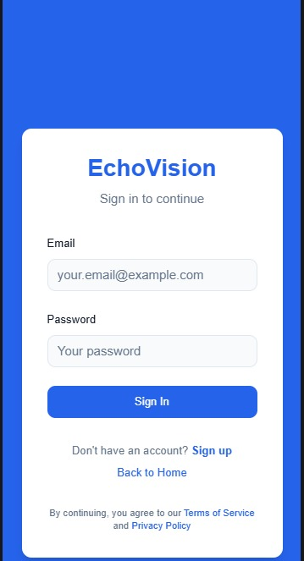

**Visual Aids**

This is the initial sign in/sign up page

**Image 1.0**

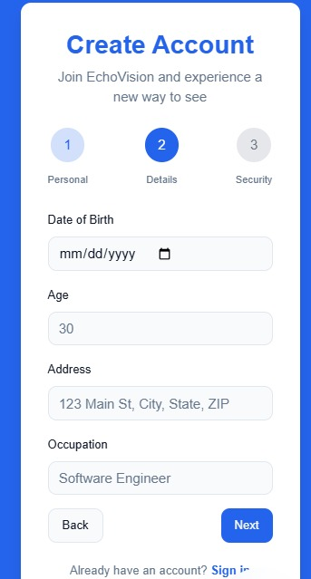

This is the initial page to create an account

**Image 1.1**

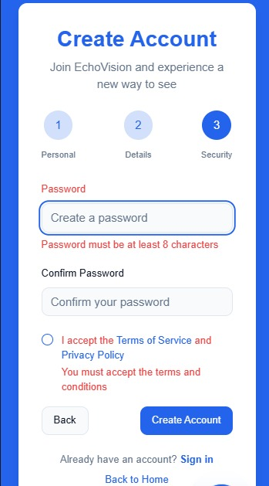

This is the initial page for creating your

Password and accepting the Terms of Service

and Privacy Policy.

**Image 1.2**

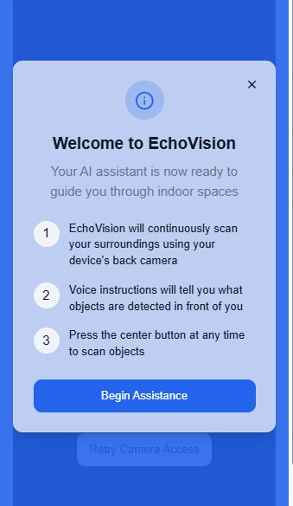

Now you are at the Welcome Page and can now

use the app to its full capabilities.

**Image 1.1**

**Terms of Services & Privacy Policy**

View the terms of services:[Terms of Services](https://id-preview--d4e5d0c7-9e3f-441d-a0e3-766555cf107e.lovable.app/terms)

View the privacy of services: [Privacy Policy](https://id-preview--d4e5d0c7-9e3f-441d-a0e3-766555cf107e.lovable.app/privacy)

**Future Expansion Possibilities**

* **Extended Environments:** Expand detection and navigation support to outdoor or more varied indoor environments.
* **Enhanced Object Recognition:** Incorporate broader object categories and dynamic hazard assessments.
* **Personalized Guidance:** Use machine learning to refine voice instructions based on user behavior and feedback.
* **Third-Party Integrations:** Integrate with additional assistive technologies and IoT devices to enhance overall user safety, for example, Meta AI glasses.
* **Subscription Model:** Users will be allowed to use a 3-day free-trial upon logging in, afterwards, they will be prompted to subscribe to our 9.99USD$/month subscription plan.

**Support and Feedback**

* **Contact Support:** If you have questions or need assistance, please reach out to our support team at [privacy@echovision.com](mailto:privacy@echovision.com)

.

* **Provide Feedback:** We value your input! Share your thoughts on the app and documentation to help us improve.

**Conclusion**

EchoVision is more than just an app; it is a transformative tool that aims to create a more inclusive world, allowing visually impaired individuals to navigate their environments with confidence and independence. We hope this documentation helps you make the most of your EchoVision experience.

**References**

University of Bath. (2025). *How blind people see the world.* University of Bath 2025. <https://www.bath.ac.uk/case-studies/how-blind-people-see-the-world/#:~:text=According%20to%20the%20World%20Health,some%20form%20of%20visual%20impairment>.